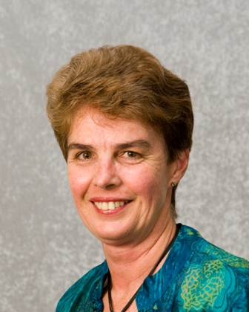IBS AR member profile

Name: Kaye Basford

Member since: 1974

Current Work Position: Professor and Head of School

Employer: The University of Queensland

Describe one of your current projects:

The Wheat Phenome Atlas project aims to construct an open source toolbox which will develop dynamically with input from a multi-disciplinary team of statisticians, computer scientists, quantitative and molecular geneticists, and wheat researchers from UQ, CIMMYT and IRRI (international agricultural research centres), and Triticarte (commercial entity responsible for developing a high-throughput genotyping protocol known as DArT). Establishing the methodology (or analytical tools) to analyse and interpret data sets of over 15,000 lines x 40 years x 80 traits x 100 locations x 2,000 DNA data points (almost 10 trillion data points) will involve the development of new and powerful bioinformatics tools and webpage visualization software. The goals are to identify elite gene blocks (e.g. for rust resistance), enhance the ability to rapidly introduce these elite gene blocks into new cultivars, and predict cultivar performance in a range of environments. The Phenome Atlas Toolbox will be free to all researchers.

What do you like about your work:

My job involves a combination of teaching, research, leadership and management, so is always varied and exciting. You can really make a difference by overcoming the many challenges which arise.

Qualifications:

1972 AMusA Australian Music Examinations Board
1974 BSc (Hons) The University of Queensland
1977 MLitSt The University of Queensland
1985 PhD The University of Queensland

Previous work history:

My initial employment was as a consulting biometrician – an experience which identified true collaboration as an excellent platform for innovative and productive outcomes. After completing my postgraduate training part-time, I was awarded a Fulbright Postdoctoral Fellowship to work with Walt Federer at Cornell University. In 1988, I subsequently joined academia at the University of Queensland where my research has focussed on developing appropriate multivariate methodology for the analysis and interpretation of genotypic adaptation in large-scale plant breeding experiments. This has resulted in two books (McLachlan and Basford (1988) on the mixture method of clustering and Basford and Tukey (1999) on graphical approaches to analysing multiresponse data), the 1998 Australian Medal for Agriculture from the Australian Institute of Agricultural Science and Technology, and a Fellowship from the Australian Academy of Technological Sciences and Engineering in 2006. In summary, my career has been at the interface between statistics and agricultural science, working with colleagues to determine the best way to extract knowledge and gain insight from plant improvement programs.

Any advice for prospective “biometricians”:

I recommend that you get involved with the scientists with whom you are working to improve your non-statistical discipline-based knowledge. This will enable you to be more effective as a biometrician and gain real insight into whatever you are investigating.

Link to relevant website:

http://www.uq.edu.au/~agkbasfo

Anything else to add:

Make sure you enjoy what you do!

